**3. Simulation Procedure**

A simulation study was conducted which allows changing parameters of interest (i.e. the number of target statistics). All simulations and analyses were conducted using R version 3.6.2 (2019-12-12)

1. **Obtaining targets**

As targets in this study, there were two scenarios. Scenario one (S1) considered two target features (prevalence at two-time points, 50 and 75) and scenario two (S2) looked at three target features (peak prevalence for each model run in addition to the two-time points in scenario one).

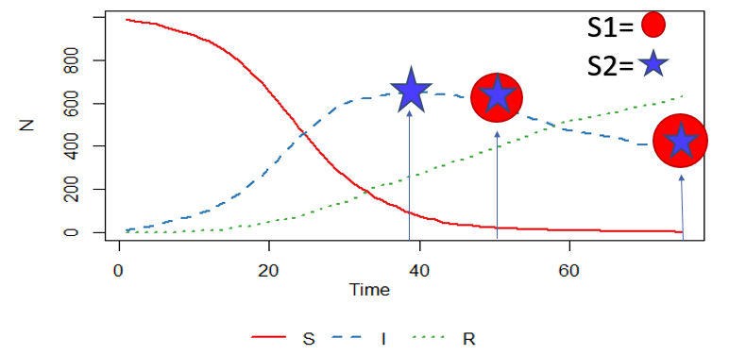

Figure 5: targets for scenarios 1 and 2. Scenario 1 considers only green points on the Infectious (I) curve while scenario 2 considers both red and green points on the (I) curve.

R version 3.6.2 (2019-12-12) was used to perform the statistical analyses and datasets were obtained from a stochastic SIR model using the SIR function in the SimInf library (siminfref). To obtain targets for scenario one, the SIR model was run one hundred times and for each run, the prevalence at times 50 and 75 were saved in a $100 x 2$ matrix. Targets for scenario one were then computed as the means of the saved prevalence at the two time points. Similarly for scenario two, the SIR model was run one hundred times and for each run, the prevalence at times 50 and 75, as well as the peak prevalence, were saved in a $100 x 3$ matrix. Targets for scenario two were then computed as the mean of the 100 stored prevalence in each column of the matrix.

1. **Obtaining a Reference (“true posterior”)**

At a sufficiently small tolerance, rejection ABC approximates the true posterior (ref: Sunnaker et al). For each scenario, we run a million simulations and saved all parameter combinations at tolerance = 1. We then chose the tolerance as low as possible in order to retain the same number of parameter combinations accepted by the methods to be compared.